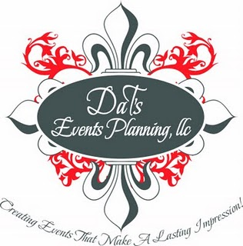

DaT’s Events Planning, LLC
Creating Events That Make A Lasting Impression!

Platinum Affair Package (Full-Service Package)
This package has been designed for the couple who wishes to focus on each other, not the hassle that sometimes come with the wedding planning process. We will meet with you to discuss your wedding vision, type of ambiance and personal style. From there we will plan, select our/your best vendors, negotiate contracts and provide you with options that best fit your vision and your budget … all you have to do is select the options you like best.
- Establish Your Wedding Theme, Style, and Overall “Feel for the Event”
- Bridal Consulting (In Person, Video Chat and via Telephone)
- Develop and Maintain Personalize Wedding Budget
- Unlimited Vendor Research & Referrals
- Unlimited Venue Research & Referrals
- Honeymoon Planning
- Assist with the selection of Wedding Attire
- Current To-Do List/Checklist provided to keep you on track with your planning, to make sure nothing gets over whelming and every detail is accounted for
- Assist with menu and bar selection
- Organize (attend when feasible) Vendor Interviews and Appointments
- Unlimited recommendations and or suggestions (i.e. creative ideas, etiquette, budgeting, decorations etc.)
- Assist with negotiation process of professional vendors
- Letter of Involvement sent to all Vendors
- Guest List & RSVP Administration
- Assist with the design of Save the Dates, Invitations, Programs, Decorations, Place Cards, Menu Cards, etc.
- Secure all equipment/décor items (purchase and or rentals)
- Itinerary Preparation and Circulation
- Supervise Itinerary Execution
- Assist with the negotiation of group room blocks for you and your guests, at conveniently located hotels
- Assist with coordinating and contracting transportation for you and your guests
- Create a Detailed Wedding Timeline and Wedding Day Schedule
- Manage Wedding Timeline with your Family, Wedding Party, Guest and Vendors
- Wedding Rehearsal Coordination
- Plan and coordinate Rehearsal Dinner (if applicable)
- Coordinate entire Wedding Day, from Start to Finish
- Distribute all Flowers (Bouquets, Boutonnieres, Corsages, etc.)
- Coordinate with DJ/Band regarding Introductions, First Dance, Cake Cutting, Bouquet and Garter Toss and Grand Exit
- Oversee all vendor commitments and make sure they are fulfilled to your standards
- Manage Wedding Gifts – Release to assigned individual for departure
- Pledge all Vendors Receive Final Payment & Gratuities
- Oversee post wedding activities (Vendor break down, Rental returns and site clean-up)
- Be your eyes and ears throughout the day so you can relax and relish your loving memories
- Provide additional staff members on your wedding day
- Wedding Kit

